Multiple-choice section – choose the correct answer

Question 1 [9.1]

Which one of the following statements is true?

A Congruent shapes look the same.

B Similar shapes can be identical.

C Two shapes are congruent if all corresponding angles and side lengths are equal.

D You only need to prove congruency if a side length is missing.

Question 2 [9.1]

Which test for similarity can be used?

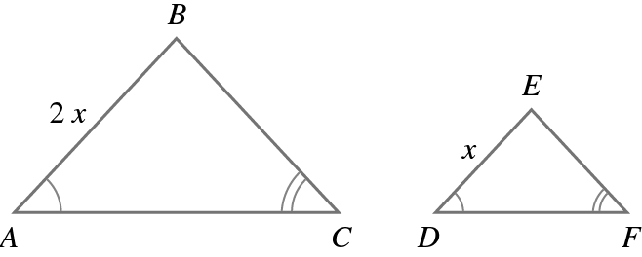

A SSS B AAA C RHS D SAS

Question 3 [9.2]

The value of x in the pair of similar triangles is:

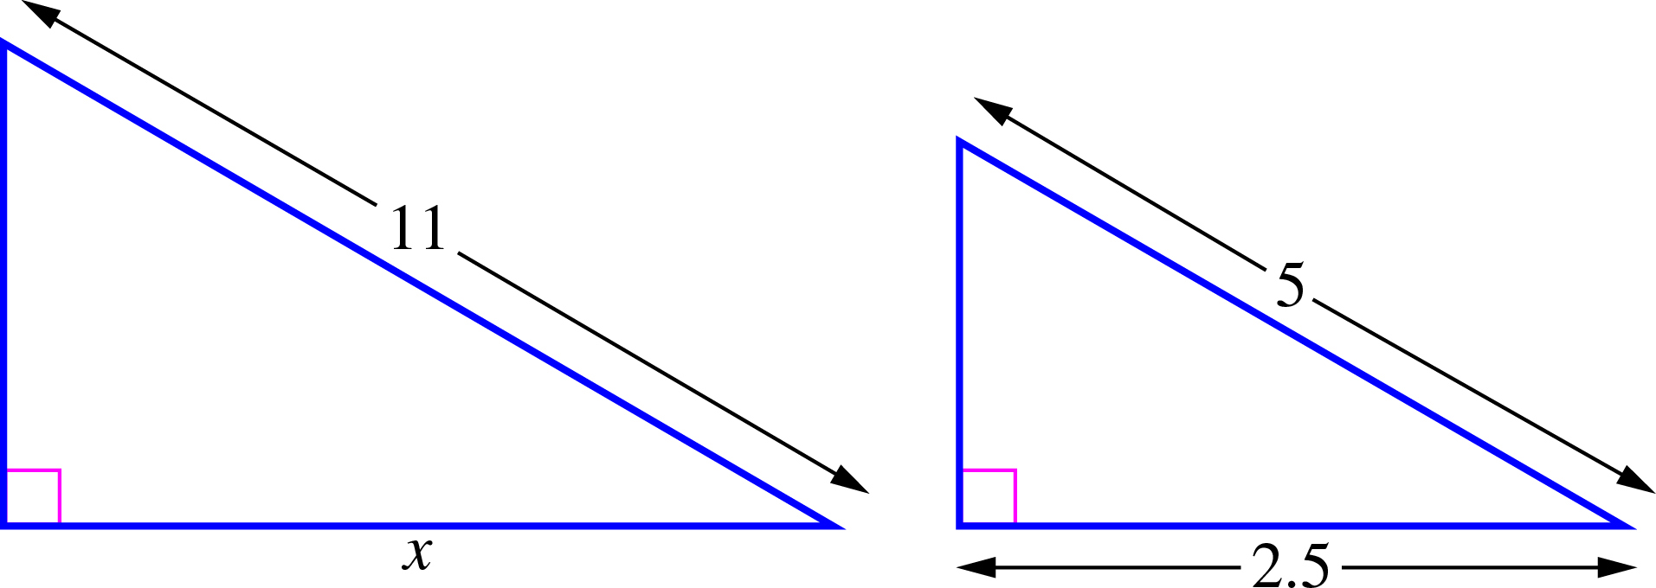

A 1.5 B 5.5 C 6 D 7.5

Question 4 [9.3]

If is similar to which statement is false?

A All corresponding sides are equal.

B = 90°

C All corresponding angles are equal.

D All of the properties for similarity apply.

Question 5 [9.3]

with can be used as part of a test for congruency because:

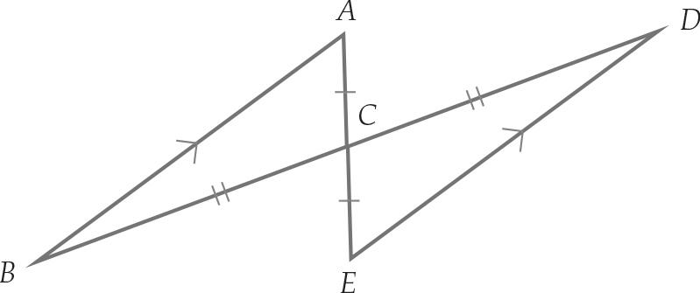

A they are alternate angles B = 180°

C the angles meet at a point D they are vertically opposite angles.

Question 6 [9.4]

For the similar triangles  QU‖TS.  
Which statement is false?

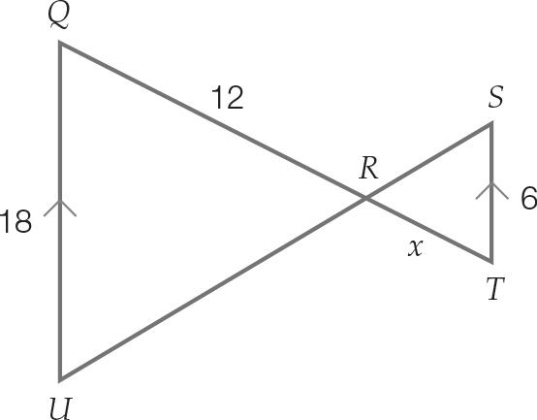

A ∠UQR = ∠TSR B The value of x is 4.

C ∠QRU = ∠SRT D ∠QUR and ∠TSR are alternate angles.

Question 7 [9.2]

Which statement is true?

A If two triangles have two corresponding side lengths and a corresponding angle equal, they are congruent using the SAS test.

B You can use any test on right-angled triangles (depending on the information given).

C If two pairs of corresponding sides of triangles have the same length, they are congruent.

D All equilateral triangles are similar shapes.

Question 8 [9.6] [10A]

What is the value of ?

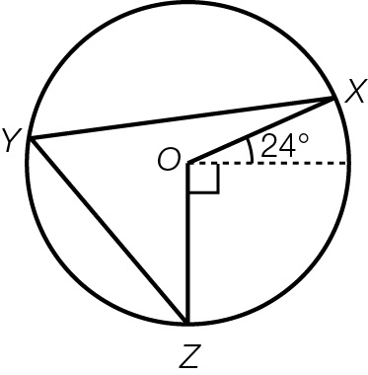

A 48° B 57° C 24° D 66°

Multiple-choice total marks: ____ / 8

Short answer section

Question 9 2 marks [9.1, 9.2]

Use words from the list below to complete the following sentences.

bisect included angle definition perpendicular bisector

congruent similar theorem perpendicular

(a) An __________ sits between two sides of a triangle.

(b) If two shapes are identical in shape and size, they are said to be ______________.

Question 10 2 marks [9.2]

Explain what are similar shapes, using an example to help you.

Question 11 4 marks [9.4]

Triangles ABC and XYZ are similar.

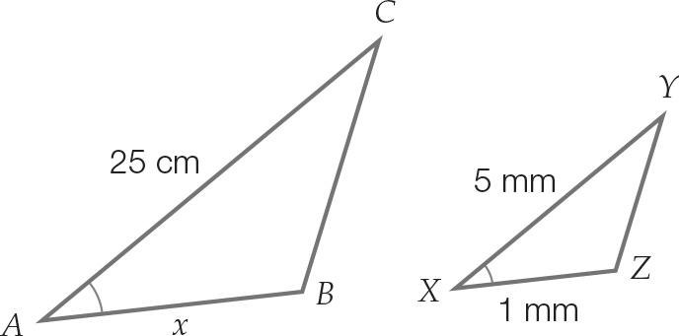

(a) State in fraction form, the side ratio.

(b) Find the value of x.

Question 12 2 marks [9.2]

Explain why testing two triangles for AAA does not guarantee congruency. Use a diagram to explain your answer.

Question 13 5 marks [9.2]

A rectangular garden of dimensions 2 m wide × 1.3 m has been expanded proportionally so that the width is now 4.3 m.

(a) Draw a sketch of the two gardens labelling the new length x m.

(b) If the old garden shape and the new shape are similar figures, what is the length of the new garden?

(c) The garden will be enlarged again, with the new length being 10.5 m.  
What will be the width of the garden now?

Question 14 3 marks [9.2]

Triangle ABC is an equilateral triangle where AD bisects BC.

(a) Show that ∆ABD and ∆ACD are congruent.

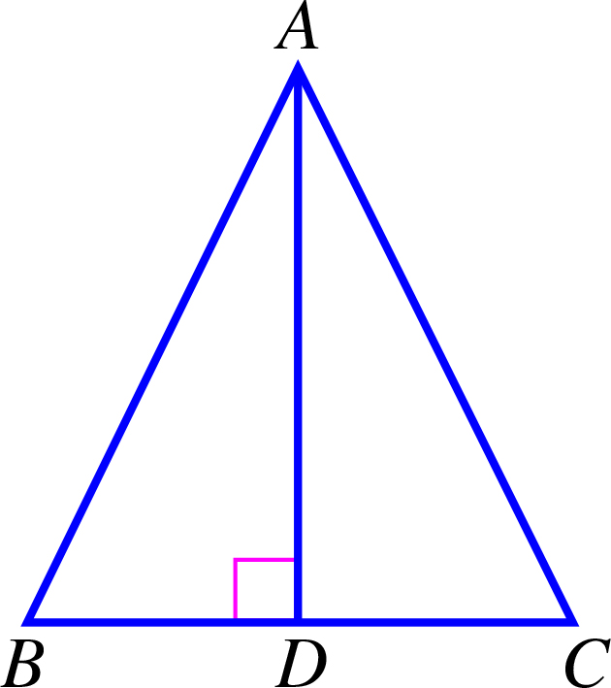

(b) Can other congruency tests be used for these triangles? If so, which other tests?

Question 15 2 marks [9.1]

The small triangles in the diagram are all equilateral.

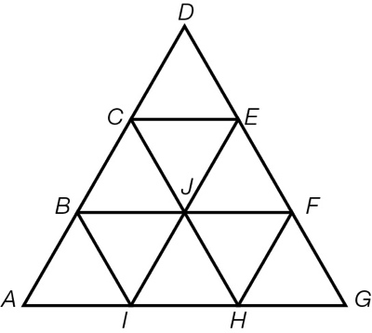

Name two different-sized triangles that are similar to 

Question 16 3 marks [9.2]

The parallelogram ACEG has midpoints at B, D, F and H.

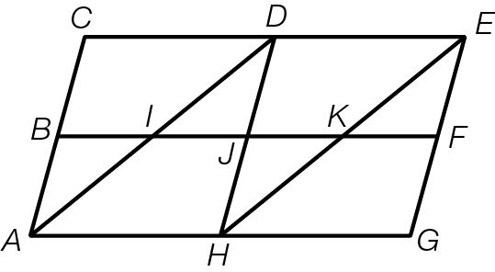

(a) List three triangles that are similar to .

(b) Which shapes are congruent to ABJH?

(c) How many pairs of vertically opposite angles are there?

Question 17 3 marks [9.3]

ABCD is a square. Prove that .

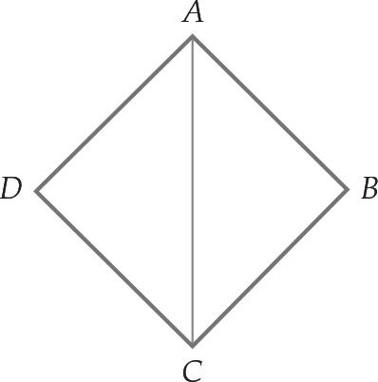

Question 18 4 marks [9.2]

A ladder rests on a 1.8 m wall with one end against a tree at a height of 7 m above the ground and the other end on the ground. If the wall is 0.6 m from the bottom of the ladder, find the:

(a) horizontal distance, in metres correct to 2 decimal places, of the base of the ladder from the bottom of the tree

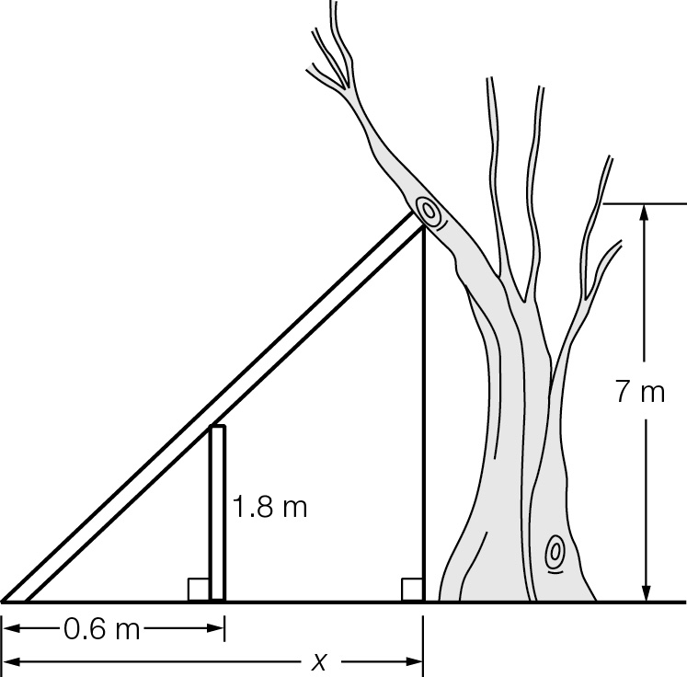

(b) horizontal distance, in metres correct to 2 decimal places, of the wall from the bottom of the tree.

Short answer total:_____ /30

Extended answer section

Question 19 3 marks [9.3]

If AE = CD, prove that ≡.

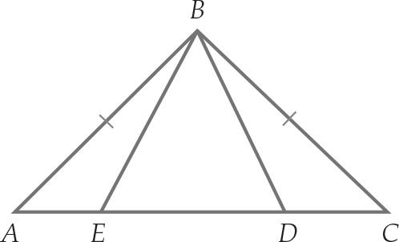

Question 20 6 marks [9.4]

(a) Why are the two triangles in the diagram similar?

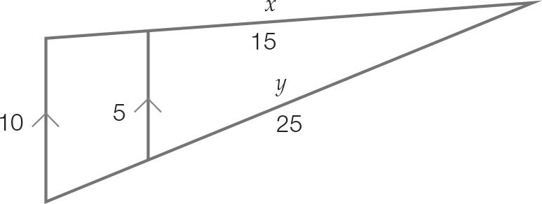

(b) Find the length of x, a side on the large triangle.

(c) Find the length of y, a side of the small triangle.

Question 21 6 marks [9.4]

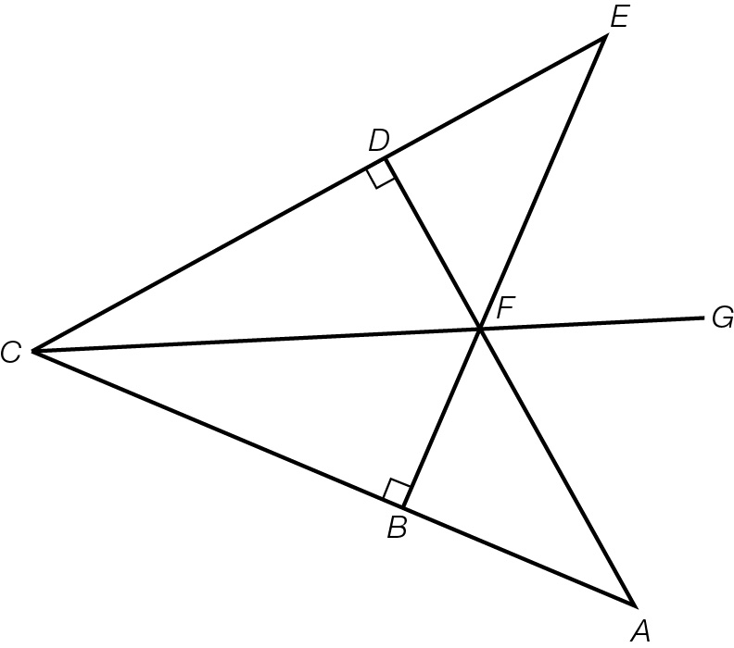

In the diagram, AC = EC and BF = DF and BC = DC.

(a) Prove that 

(b) Prove that 

(c) Prove that CG bisects 

Question 22 4 marks [9.6] [10A]

Point O is the centre of the circle. Show that:

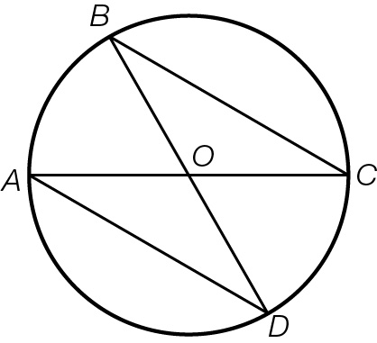

(a) 

(b) 

Extended answer total:______ / 19

TOTAL test results: ______ / 57